 **NARROGIN SENIOR HIGH SCHOOL** 

**English ATAR Year 12**

|  |
| --- |
| **Student:**  **Date handed out: Monday 22nd June 2020**  **Date Due:** **Monday 29th June 2020** |
| **Assessment Type:** Responding  **Task 10**  Answer the questions from the Semester One examination in short answer responses of 250-300 words per response.  **The expectation is your response will be significantly improved as you have:**   * **The marking key** * **Feedback on your responses** * **Teacher input regarding each text and question** * **Four periods to work on three responses** * **Access to teacher support while you are working on the responses**   **Time allocation:** Four periods in class.    **Weighting:** 5%  **Mark: / 30** |

|  |  |  |  |
| --- | --- | --- | --- |
| **To be assessed for this task you must submit:** | **Date Due** | **YES** | **NO** |
| Short answer responses | **Monday 29th June** |  |  |
| The original responses and Marking Key from the examination | **Monday 29th June** |  |  |
| A reflection that itemises A**ND** explains what you have learnt about Responding to Short Answer Responses. Half to one page. | **Monday 29th June** |  |  |

Question 1 (10 marks)

Show how language features communicate ideas about rafting to engage readers in **Text 1**.

**Text 1**: Extract from the article ‘Come hell or high water’ by Ross Bilton, (2020).

|  |  |
| --- | --- |
| **Suggested mark allocation for Question 1** | **Marks** |
| The quality and number of points made in relation to the question.  **Language features**   * Humorous names that convey characteristic aspects of the river for rafters. * Representations of people and events, the environment. * The use of ellipsis, variation of syntax, parenthesis, punctuation for effect, an engaging tone, alliteration, italics for effect, onomatopoeia. * Figurative language, simile, descriptive language and imagery, personification. * Emotive language, colloquial language, a friendly style of writing. * Humour and language for dramatic effect. * Facts and rafting terminology. * Juxtaposition ‘the campsite is abysmal, but morale remains high’. * Direct speech to communicate camaraderie and team spirit. * Symbolism – connotation of ‘morale socks’ for comfort. * Anecdote to communicate human interest. | **0 – 4** |
| **Ideas**   * That river rafting can be dangerous, difficult and hard work. * Comradery and a sense of group morale and team support. * Adventure, the thrill of the outdoors. * The beauty of being up close to nature, the experience of camping in the wilderness. * That adventure is not restricted to age or gender. * Of time having little meaning in nature. | **0 – 3** |
| **Readers**   * Readers of The Weekend Australian. | **0 – 1** |
| **Expression**  The extent to which the candidate expresses their responses clearly and concisely and integrates examples and/or brief quotes to support their response. | **0 – 2** |
| **Total** | **10** |

Question 2 (10 marks)

Analyse the way visual choices connect a target audience to key ideas and purpose in **Text 2**.

**Text 2**: A copy of the Women's Adventure Magazine cover published in 2012.

|  |  |
| --- | --- |
| **Description** | **Marks** |
| The quality and number of points made in relation to the question.  **Visual choices**   * The masthead which identifies the brand and target audience. * Outdoor setting which features wilderness and natural beauty – this being a spring issue there are flowers that signify the season. * Composition which foregrounds a well-known ultramarathon athlete for inspiration to promote sales. * Dress codes that convey the time of year, idea of being feminine and athletic. * Expression and full body action shot to show physical fitness. * Symbolic objects - water bottles, fitness watch and running vest suggest endurance and long-distance capability. * Variation and placement of font for emphasis and interesting features. * Language features: repetition, alliteration, parenthesis, tone, punctuation for effect, emotive language, jargon that relates to equipment, catchy rhyme ‘thrive in the wild’, assertive language. * Selection of detail, emphasis on action, speed, doing more outdoors, being fit and healthy. * The barcode to facilitate purpose and sales. | **0 – 4** |
| **Key Ideas**   * That adventure is not just for males – and that women can even better male competitors. * That athletes can be feminine and yet engage with rugged terrains and challenging sports. * Adventure can be a way to experience cultural diversity, help communities and the planet. * That there are many ways to enjoy outdoor adventure: cycling, horseback, running, kayaking. * The magazine offers ways to improve training, essential products, first-hand accounts and insights, tips for travelling and even inspirational viewpoints. | **0 – 3** |
| **Target audience**   * Women who regularly subscribe to this magazine or wish to buy it. * Athletes who follow Krissy Moehl’s advice and want to know more. * Women who are interesting in outdoor fitness, who are adventurous and sporty. * Readers who enjoy a broader perspective of exploring such as cultural diversity, community service, environmental sustainability. * Competitive women who are not limited by gender expectations of adventure. * Contemporary women who are empowered to take up challenging sports. | **0 – 1** |
| **Expression**  The extent to which the candidate expresses their responses clearly and concisely and integrates examples and/or brief quotes to support their response. | **0 – 2** |
| **Total** | **10** |

Question 3 (10 marks)

Explain how techniques and conventions influence response and relate to the mode of **Text 3**.

**Text 3**: An extract from David Attenborough’s speech for the 2019 World Economic Forum.

|  |  |
| --- | --- |
| **Description** | **Marks** |
| The quality and number of points made in relation to the question.  **Mode**   * A speech at the 2019 World Economic Forum. | **0 – 1** |
| **Techniques**   * Facts which create credibility and dramatic effect. * Language features: dramatic pauses, variation of syntax, repetition, exclamation, inclusive language that positions response, a convincing tone. * Analogy ‘The Garden of Eden’ to emphasise the idealistic past. * Humour to engage listeners, selection of detail. * Scientific jargon, facts and authority to show authority. * Juxtaposition to reinforce contrasting ideas, the past and the present. * An assertive tone that communicates a sense of urgency. * A style that acknowledges audience – information pitched to an academic level of reception. | **0 – 4** |
| **Conventions of speech**   * First person point of view. * Anecdote and opinion. * Persuasive language, inclusive and emotive language, repetition, punctuation for dramatic effect. * Communication of ideas that shape purpose: planning for the future, internet accessibility to facts, humanity and survival, sustainability. * Values such as sustainability, responsibility. | **0 – 3** |
| **Expression**  The extent to which the candidate expresses their responses clearly and concisely and integrates examples and/or brief quotes to support their response. | **0 – 2** |
| **Total** | **10** |

Question 1 (10 marks)

Show how language features communicate ideas about rafting to engage readers in **Text 1**.

**Text 1**

*Extract from the article* ‘Come hell or high water’ *by Ross Bilton, The Weekend Australian (2020).*

Nasty Notch. Pig’s Trough. The Crankle and The Cauldron. Duck Shoot and Side Winder and the Walls of Jericho... for anyone who loves to pore over names on a map, the Franklin River is a gift. Right now, we’re contemplating a rapid in the Great Ravine with another evocative name: the Churn. Paddling is out of the question; even a straightforward portage1 is impossible in these high-water conditions. Our only option is to unload and deflate the three rafts and haul everything – half a tonne of gear– up a steep rock face with a fixed hand-line, then onto a gnarly track that ascends a steep ridge before dropping sharply down the other side, where the boats can be reinflated, repacked and lowered into the river.

Bypassing the Churn – a mere 150 m of the river – takes more than five hours of hard labour. We cover the next 150 m on the water in about 20 seconds. That afternoon, exhausted, we pull into Rafters Basin, where we’ll be stuck by rising water for another three days. The campsite is abysmal, but morale remains high, thanks to endless card games orchestrated by Victorian vet Liz and her four teenagers, and great camp food. I’ve bought a small tent (most of the others are under tarps, desperately digging drainage channels around their sleeping mats) and I spend my time reading, dozing and listening to nature’s symphony: the thunderous white noise of the river, percussive splats of fat raindrops on the flysheet of my tent, trees hissing and squeaking as they sway in the wind.

We all have our way of keeping our spirits up; Sam tells us she’s managed, against all odds, to keep a single pair of socks dry for evening wear. “Morale Socks,” she calls them. “That’s the move, Sam!” says our expedition leader, Chris. Morale stays high even on the second day stuck there, when we’re told our food will now be rationed, as there’s no way of telling when we might get out. Mark, a former SAS trooper, recounts the story of Alexander Pearce, an escaped convict who traversed this country in the 1820s and subsisted by cannibalising his companions. We laugh, of course; we laugh like drains. Then each one of us steals furtive, assessing glances at the others, like, *So, who will we eat first?*

1 Portage is the practice of carrying watercraft or cargo over land.

Question 2 (10 marks)

Analyse the way visual choices connect a target audience to key ideas and purpose in **Text 2**.

**Text 2**

*A copy of* Women's Adventure Magazine *cover with ultramarathon athlete Krissy Moehl (2012).*

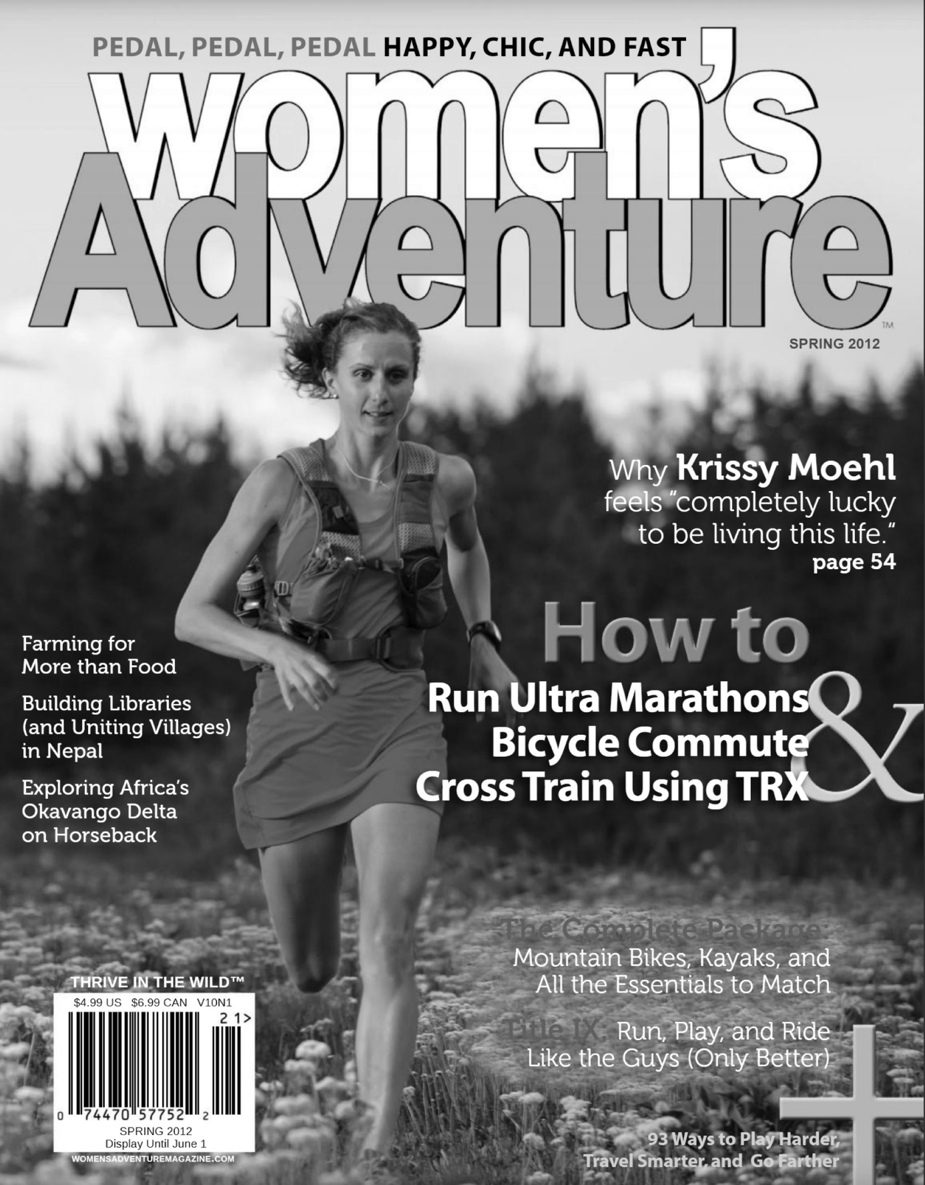

Question 3 (10 marks)

Explain how techniques and conventions influence response and relate to the mode of **Text 3**.

**Text 3**

*An extract from David Attenborough’s speech for the 2019 World Economic Forum.*

I am quite literally from another age. I was born during the Holocene – a 12 000-year period of climatic stability that allowed humans to settle, farm and create civilisations. Global businesses, international co-operation and higher ideals are all possible because for millennia, nature has been largely predictable and stable. Now, in the space of one human lifetime – indeed in my lifetime, all that has changed. The Garden of Eden is no more. We have changed the world so much that scientists say we are in a new geological age – The Anthropocene - The Age of Humans. When you think about it, there is perhaps no more unsettling thought. The only conditions modern humans have ever known are changing and changing fast. It’s tempting to ignore evidence and carry on as usual or to be filled with doom and gloom. But we need to move beyond guilt or blame and get on with the practical tasks at hand. We did not get to this point deliberately – and it has happened astonishingly quickly.

When I first made television programs most audiences had never even seen a pangolin – indeed few pangolins had ever seen a TV camera! When I made a series of life on earth in 1979, I was aware of environmental problems, but I never imagined we were fundamentally changing nature. In 1999, whilst making the Blue Planet series, we filmed coral-bleaching and I still didn’t appreciate the magnitude of damage. Now, we have more knowledge and can share evidence on an unimaginable scale. Movements and ideas spread at astonishing speed. The audience for my first series, 60 years ago, was restricted to a few million viewers in southern England. My latest series – Our Planet – will go *instantly* to hundreds of millions of people in almost every country via Netflix. The evidence behind it will be free to everyone with an internet connection. If people can truly understand what is at stake, I believe they will allow governments to get on with practical solutions. As a species we are expert problem-solvers. We can create a world with clean air and water, unlimited energy, and fish stocks that will sustain us.

But we need a plan. Because what we do will profoundly affect our future.